AI and Computer Chess in the Netherlands
Jaap van den Herik

Genna Sosonko was sure in August 1980: “The computer is going to win. Man has no chance.” Among the top Dutch chess players, he was the only one who thought so. It was an almost 'Donnerian' position he took. With his outspoken position, Sosonko wanted to say: “That's how it is, that's how it will happen, you don't have to doubt this.” As a contrast, I also mention Hein Donner's statement in NRC Handelsblad (1981), namely that “the computer will have no chance against man for the next few centuries”.

With some nuance, Jan Timman (June 1980) expresses the same opinion as Donner when he stated: “At the moment I believe that 2500 Elo points is feasible, in principle.” He also opined: “An endgame study always remains creative human work “ (interview in Newsletter 100, December 2021, from the Max Euwe Center). Around 1980, whether or not stronger than humans was in full discussion among many chess players who could not believe that a machine would beat them. Fortunately, there was room for discussion within the KNSB!

Technology is indeed an interesting topic. Obviously, we find many sensible people among the chess players. I will mention four of them, namely two professors (Euwe and De Groot) and two computer chess experts from the very beginning (Swets and Van Diepen). This is followed by a description of the development of computer chess and an overview of thoughts on the future of the then ongoing research.

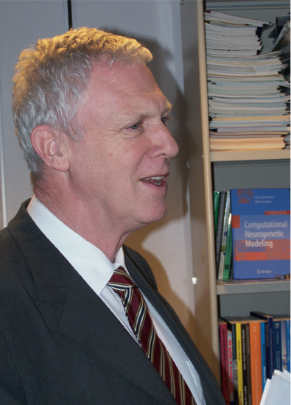
From the very beginning, Professor Jaap van den Herik was one of the great stimulators of computer chess worldwide. Photo Eric van Reem.
Euwe and de Groot
Max Euwe and Adrian de Groot were respected scientists in 1961.With their research groups, they co-submitted a prestigious research application project at Euratom. It was assigned to their consortium and work had to be started. The project was about automating all kind of intellectual activities. The far-away goal was automatic translation. “That is too far in the future”, Euwe said, “so let's start with a computer program that can play chess well” The project turned out not to become a success. Two reports were written (out of disagreement) and Euwe (1963) took on the task of writing the computer chess part. It was a good preparation for Euwe as a top mediator in the Spassky-Fischer match (1972). The project was satisfactorily completed and the reports disappeared in many drawers.

Swets and van Diepen
Swets and Van Diepen were two newcomers. Barend Swets designed the program BS '66 '76 and Peter van Diepen designed IGM. They were talented front runners. In the 1960s Swets was the very first computer chess programmer in the Netherlands. He was a student of mathematics at the Delft University of Technology. Van Diepen did appear on the scene in the late 1970s. He had connections with Hoogovens and with the Hobby Computer Club (HCC). There were also other programmers who followed the chess line with interest.
BS’66’76 came out first and played in the first European Computer Chess Championship (ECCC) in Amsterdam (1976). The following year (1977) BS 6676 (now unquoted as sign of maturity) played in the second World Computer Chess Championship (WCCC) in Toronto. There the ICCA was founded (a brainchild of Barend Swets). Ben Mittman became the first President of the ICCA (International Computer Chess Association) and also Editor of the ICCA Newsletter. In 1979 Swets and Van Diepen unofficially played for the Championship of the Netherlands. BS 6676 won by 2-0. The second time (1980) the title was shared. Then, only one game was played, it took way too many hours (result: draw, three times same position, IGM had a winning position, but did not understand how to materialize that. BS 6676 was happy). In brief the ingredients for a successful computer chess development were ready. All that remained was to realise the promises.
At that time Euwe took the lead in the Netherlands. In the spring of 1980 he proposed to me that a Computer Chess Department should be started within the Alexander Rueb foundation. Alexander Rueb (1882-1959) was one of the founders of the World Chess Federation FIDE (Fédération Internationale Des Échecs) in 1924 and also its first chairman from 1924 to 1949. The Rueb Foundation handled Alexander’s collection of chess books and magazines. The library is housed in the University Library of Amsterdam.
Establishment of a new association
“If all goes well”, Euwe stated, “then we should start a Computer Chess Association Netherlands (CSVN)”. Indeed everything went smoothly. Hence the CSVN was founded in Utrecht on October 18, 1980 as an official subgroup of the KNSB. Of course, it all had to be arranged properly. That happened on April 25, 1981. The first chairman was Jaap van Oosterwijk Bruyn. There was started an own magazine, there were also announced a national championship and much attention was given to community building.

These activities stimulated the association and were certainly instrumental for the fact that the Netherlands reached somewhat later the world top in computer chess. This happened on two fronts: with microcomputers (in 1985 and 1991) and with mainframe computers (in 1992 and 1995). From 1980 to 2001, in addition to the regular WCCCs (world computer chess championships), the ICCA also organised a separate cycle of world championships particularly for microprocessors. In 1985 and later on, an official distinction was made between professionals and amateurs.

In brief, we will summarise below the history to some extent. In 1970 the first North American Computer Chess Championship (NACCC) was played in the USA. In 1974 the International Federation for information Processing (IFIP) organised the first WCCC in Stockholm. The second WCCC was in Toronto (1977) and the third in Linz (1980). There were no Dutch participants in Linz. The program Pioner (Botvinnik), which everyone was looking forward to, cancelled at the very last minute participation. Additionally, it is remarked here that in the context of computer chess research Jaap van den Herik defended his Ph.D. thesis supervised by Professors Henk Lombaers, Adrian de Groot and Joop Doorman. In Linz van den Herik recorded expert opinions on the future progress of Computer Chess research from Claude Shannon, Ken Thompson and many other top specialists in this field. On June 21, 1983, the official ceremony took place. It was the second AI thesis in the Netherlands.

Computer Chess Championship of the Netherlands
After the successful start of the CSVN, the developments went fast, both in terms of organisation and research. The first official Dutch Computer Chess Championship took place in Utrecht (October 1981). Candidates for first place were the programs BS 6676, IGM and Pion (TU Delft). But the result turned out to be fully different. Thirteen programs had applied. The first three places were: 1. YNCT 1.0 (Luuk de Vries, You Never Can Tell) 7.5 out of 9; 2. Gambiet'81 (Wim Rens) 7; 3. Pion (TU Delft) 6. With that, two new top programmers had presented themselves. After the tournament YNCT 1.0 played many demonstration games and Wim Rens brought his program Gambiet to the commercial market. The next year, Gambiet'82 and YNCT 2.0 switched positions. Still, the pattern of new talents emerging repeated themselves in the following years. In this overview we now concentrate on two absolute toppers.

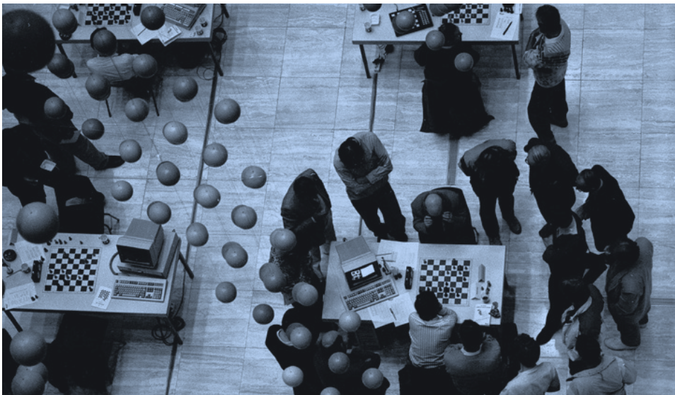
The Aegon tournament between humans and computers was unique in its kind in the 1990s. Photo Bas Beekhuizen.

Ed Schröder and Frans Morsch
In the 5th WCCC (Cologne, 1986) four Dutch programs participated. The program Rebel (Ed Schröder) started with 3 out of 3 (including a win against Sun Phoenix). This start put Rebel on the first place together with Hitech (Hans Berliner, Carnegie Mellon University). In the last two rounds Rebel played against Hitech and Bebe; Rebel lost twice and thus finished with 3 out of 5 in a tie for fifth place. All in all, Schröder's place was a very remarkable achievement. He had handed over his business card, implicitly promising that things could be much better. He had so many new ideas. Two other Dutch participants also achieved a score of 3 out of 5, namely Nona (Frans Morsch) and Dutch (TU Delft, previously Pion). In the 6th WCCC (Edmonton, 1989) five Dutch programs participated, but none of them ended in the top.

After five years of very hard work Ed Schröder saw the first breakthrough in Vancouver (1991). With the Chess Machine Gidéon he won the WMCC title: World Microcomputer Chess Champion 1991.

in the 7th WCCC (Madrid, 1992) all his efforts really paid off. Chess Machine Schröder took the title of world champion in all divisions. This meant that a simple microcomputer among mainframe computers and supercomputers became world champions in all categories, an unprecedented achievement at the time.

It was a great stimulus for many Dutch programmers. Frans Morsch was one of them. He already had quite a track record back then. To begin with, as an amateur he was the first world computer chess champion among microcomputers (Amsterdam, 1985), but the real peaks were still ahead of him. In 1991 he started a partnership with Matthias Feist and therefore worked a lot with Computer Schach und Spiele.

The reward was great. in the 8th WCCC (Hong Kong, 1995) their program Fritz really became world champion in the midst of sophisticated mainframe computers and other supercomputers. in the penultimate round Fritz convincingly defeated Deep Blue (IBM - Carnegie Mellon University). Through Morsch and Feist, the Netherlands had proven its supremacy. This led to great disappointment for IBM and Carnegie Mellon, as they were counting on a world title and the immediate subsequent challenge of human world champion Garry Kasparov. Frans Morsch had robbed IBM of a boyhood dream and had himself shown what his Fritz program was worth. What now?

Deep Blue contra Kasparov
C.J. Tan (IBM) was very honest in the discussions. “This is a very, very big disappointment for me, for IBM, for our world. you understand that IBM is not going to organise a match for a non-IBM program.' In brief, the world board said stalemate. The loss was completely justified, Fritz was well prepared, Deep Blue had no chance in the match. in fact, it was nowhere exciting. again, chapeau bass for Frans Morsch and Matthias Feist. Nevertheless, important steps had to be taken quickly. One more round to go and then the press releases with the announcement of the match between Deep Blue and the Human World Champion were at stake. What form would this take? in what terms? And what did the IBM management think of the current development?

The further course went as it went, not Fritz but Deep Blue played in 1996 against Kasparov. Kasparov won, after which Deep Blue exercised its right to revenge. In 1997 Deep Blue won (surprisingly for some) against Kasparov, who had not stipulated a right to revenge in the new 1997 contract. During the negotiations, he could not imagine that he could lose. For a long time, Deep Blue's victory over Kasparov was considered a single point of knowledge. Kasparov certainly wanted revenge, but IBM never let Deep Blue play again. In summary, the technology was not accessible to science. Let alone for the common man.

Meanwhile, Frans Morsch continued with Matthias Feist to upgrade their program. Would they be able to match or even exceed IBM's performance? They did their best and more than that.

Computer in the ‘human’ Dutch Chess Championship
In 2000, KNSB board member Sytze Faber approached me with the question: “Jaap, what do you think of having a chess program participate in the regular Dutch Championship? There were many obstacles. Yet this was the method to bring artificial intelligence to the attention of society, the sports world, business, politics and radio and television. To enthuse the chess players, the prize money had to be increased from 100,000 to 170,000 guilders. Fortunately, additional sponsors were found. The tournament could start on April 1, 2000. It was won by Loek van Wely, ahead of Jeroen Piket. Paul van der Sterren, Fritz “SSS*, and Sergei Tiviakov shared the third place. Kudos to the KNSB for their courage to start this experiment and for managing to connect sport and science.

Matches against Kramnik
The Dutch Championship 2000 was a great stimulus for Morsch and Feist. They continued with even more energy to improve their program. Their goal was not to beat the Dutch Champion Van Wely, but the World Champion Vladimir Kramnik. And indeed, with a much improved Fritz they played against Kramnik in 2004. The match ended in 4-4. So they were equally strong. However their goal was not yet achieved. So, Morsch and Feist continued to work hard by tuning and improving their program. It wasn't until 2006 that they could reap the rewards of their hard work. That was done by Deep Fritz, in a new match against Vladimir Kramnik (4-2).
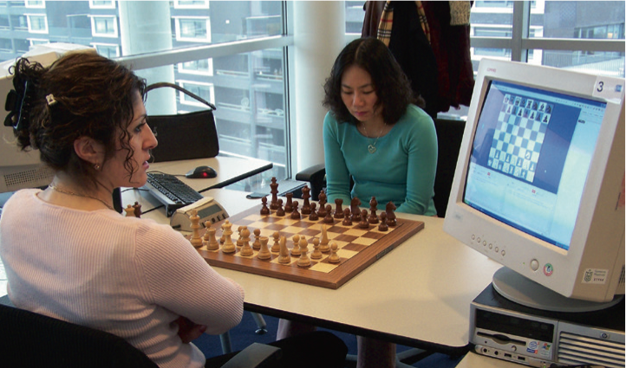
Humans can also play with the help of the computer, as the top players Peng and Lanchava showed in Maastricht in 2006. Photo Eric van Reem.

Turnaround and Cheating
Since Deep Fritz was commercially available at the time, we can safely state that from that moment on, there has been a social revolution is society. From 2006, every spectator (in the hall of a chess tournament, and in the world at large) who follows a match with the help of a computer knows what is the best move. Only the two players on the stage who are playing, e.g., for the world title do not know. Of course, the rules for being in the tournament hall were adjusted. Spectators with a mobile phone were no longer welcome, because whisperers sometimes speak too loudly. Even if this is in good faith, talking or communicating will make cheating possible.

In 2004, GM Arkadi Naiditsch was caught for cheating when using a computer program in internet chess. In 2006 at the World Open, two players were disqualified. They wore a hidden earpiece by which they received moves whispered by a companion who used a supercomputer. In 2010, three players from the French team participating in the Olympiad in Ukraine were suspended due to remote computer use. In the autumn of 2022, another shock followed in the chess world: world champion Magnus Carlsen expressed a suspicion of cheating towards GM Hans Niemann.

Self-Learning Machines
In order to form our own opinion about the possible enrichment of chess by computer chess, we also need to know a number of other developments. In brief, these are (1) self-learning machines and (2) the observation that human knowledge is fallible. Since 2000 most programs had already built in a mechanism that automatically corrected a bad opening library result (the simplest correction: never play the variation again).

What happened is that the machines became more and more powerful, the programs could search, time and again more deeply. Furthermore they were able (3) to include database patterns in their variant calculations. In summary, pattern recognition became an important part of any strong-playing program. The deeper you look, the more you see. And that's how we came to (4) deep learning in 2016.

To the outside world, this manifested itself with Alpha-Go against-Lee Sedol, and then with the convincing defeat of the strongest recognized human world champion Go, nineteen-year-old Ke Jie in 2017.

Deep learning even had the ability to learn from the starting position (thus avoiding all the mistakes in the opening book). After showing their power for Go, these techniques were also implemented in the Chess and Shogi programs. The world was turned upside down and the Royal Dutch Chess Federation (KNSB) made frantic efforts to keep up.

We also refer to Karel van Delft's weekly publications in the Newsletter of the Chess Academy Apeldoorn (download number 235 for example). Attention to computer chess is provided by Jeroen Noomen. In his Section you then will see games from the computer engines (including Stock fish with a rating of 3585, more than 700 Elo points higher than the human World Champion Carlsen with 2865).

How computer chess has enriched chess
Below we show a list of eleven points where computer chess clearly has changed/enriched chess. The list can be easily expanded. It is on (1) the formation of ideas and (2) the question of how computer chess has changed the original aims of chess.

- Removal of adjourned games
- Improved opening preparation
- Faultless endgame databases (e.g., the endgame KNNkp))
- Detecting cooked problems (e.g., if a mate-in-2 has two has different solutions)
- Corrections of endgame studies
- Changing the Nature of Correspondence Chess
- Supporting journalists and commentators
- Correcting analyses of published (World Championship) games
- Detecting differences in playing style between IGMs and programs
- Computer Chess is a prime example of technological innovation
11. The Twelve Aegon Tournaments 1986-1997

In 1986 Cock de Gorter started a human-computer tournament with the support of Aegon and the CSVN. The tournament has known twelve editions. In 1996 is has grown to a great crowded attraction, among others, the grandmasters Bronstein, Christiansen, Vaganian, Seirawan, Speelman, Kosashvili, Van der Wiel and Ree participated.

Can we solve the game?
In all our considerations we have left one point undiscussed. We have argued and shown that it is possible to realise a computer program that plays stronger than the world champion. The remaining question is now: can we in game-theoretical terms solve the game of chess? By this we mean (with perfect play on both sides): can the game of chess be characterized as

1. Won for white;
2. Draw;
3. Won for black?
[At 3. you can think of zugzwang.]

I first discussed this question at a seminar (Ph.D. defense Aleksander Sadikov) in Ljubljana (2005). My answer then and now was and is:

- Yes, it is possible to completely solve the game.
- I believe this will take place before January 1, 2035.
- I expect the game of chess to be a draw.

A small explanation of this bouncer may be in order.

Ad 1 Chess is a finite game with 10 to the power of 43 (a 1 with 43 zeros) different positions. Due to the 50-move rule (with some exceptions for more moves) and the draw rule for three times the same position, there is one outcome for each side (1-0, 1⁄2-1⁄2, or 0-1). If both sides play perfectly (i.e., make no mistakes), then we call the outcome the solution of the game of chess.

Ad 2 The date of January 1, 2035 can be compared to my earlier predictions (e.g., a bet with Hans Böhm, concluded in July 1979) regarding the playing strength. Those predictions were there

- on January 1, 1990 a chess program would have a rating of 2600
- on January 1, 1995 a chess program would have a rating of 2650
- on January 1, 2000 a chess program would be stronger than human chess world champion (that is, the human world champion was by then defeated in a match).

Ad 3 My prediction for the game-theoretic outcome of the game of chess is a draw. This would qualify chess as a fair game. Although there is also an additional note to make, namely if there is only one way to a draw and the rest is all won for white, then the word 'fair' should be defined in a special way.

Note: The article is an edited version of
Assistent en Concurrent van de Mens - Computerschaak
by Jaap van den Herik
published in
150 jaar KNSB – Schaakland vol verhalen
Editors: Peter Boel, Frank Clevers en Minze bij de Weg

